# Project Report - Business Problem Analysis for identifying neighborhood for Indian restaurant

**Introduction:**

The City of New York, being the most populous city in the United States and situated on one of the world's largest natural harbors. It is diverse and is the financial capital of USA. It is multicultural. It provides lot of business opportunities and business friendly environment. It has attracted many different players into the market. It is a global hub of business and commerce. The city is a major center for banking and finance, retailing, world trade, transportation, tourism, real estate, new media, traditional media, advertising, legal services, accountancy, insurance, theater, fashion, and the arts in the United States. This also means that the market is highly competitive. As it is highly developed city so cost of doing business is also one of the highest. Thus, any new business venture or expansion needs to be analyzed carefully. The insights derived from analysis will give good understanding of the business environment which help in strategically targeting the market. This will help in reduction of risk. And the Return on Investment will be reasonable.

New York City's food culture includes an array of international cuisines influenced by the city's immigrant history. [Central](https://en.wikipedia.org/wiki/Central_Europe) and [Eastern European](https://en.wikipedia.org/wiki/Eastern_European) immigrants, especially [Jewish](https://en.wikipedia.org/wiki/Jewish_Americans) immigrants from those regions, brought [bagels](https://en.wikipedia.org/wiki/Bagel), [cheesecake](https://en.wikipedia.org/wiki/Cheesecake#North_America), [hot dogs](https://en.wikipedia.org/wiki/Hot_dog), [knishes](https://en.wikipedia.org/wiki/Knish), and [delicatessens](https://en.wikipedia.org/wiki/Delicatessens) (or [delis](https://en.wikipedia.org/wiki/Delis)) to the city. [Italian](https://en.wikipedia.org/wiki/Italian_diaspora) immigrants brought [New York-style pizza](https://en.wikipedia.org/wiki/New_York-style_pizza) and [Italian cuisine](https://en.wikipedia.org/wiki/Italian_cuisine) into the city, while Jewish immigrants and [Irish](https://en.wikipedia.org/wiki/Irish_diaspora) immigrants brought [pastrami](https://en.wikipedia.org/wiki/Pastrami) and [corned beef](https://en.wikipedia.org/wiki/Corned_beef), respectively. [Chinese](https://en.wikipedia.org/wiki/Chinese_restaurant) and other Asian restaurants, [sandwich](https://en.wikipedia.org/wiki/Sandwich) joints, [trattorias](https://en.wikipedia.org/wiki/Trattoria), [diners](https://en.wikipedia.org/wiki/Diner), and [coffeehouses](https://en.wikipedia.org/wiki/Coffeehouse) are ubiquitous throughout the city. Some 4,000 mobile food vendors licensed by the city, many immigrant-owned, have made [Middle Eastern](https://en.wikipedia.org/wiki/Middle_East) foods such as [falafel](https://en.wikipedia.org/wiki/Falafel) and [kebabs](https://en.wikipedia.org/wiki/Kebab) examples of modern New York [street food](https://en.wikipedia.org/wiki/Street_food). The city is home to "nearly one thousand of the finest and most diverse [haute cuisine](https://en.wikipedia.org/wiki/Haute_cuisine) restaurants in the world", according to [Michelin](https://en.wikipedia.org/wiki/Michelin). The [New York City Department of Health and Mental Hygiene](https://en.wikipedia.org/wiki/New_York_City_Department_of_Health_and_Mental_Hygiene) assigns letter grades to the city's restaurants based upon their inspection results. As of 2019, there were 27,043 restaurants in the city, up from 24,865 in 2017. The Queens Night Market in [Flushing Meadows–Corona Park](https://en.wikipedia.org/wiki/Flushing_Meadows%E2%80%93Corona_Park) attracts over 10,000 people nightly to sample food from over 85 countries.

**Business problem**

The City of New York is famous for its excellent cuisine. It's food culture includes an array of international cuisines influenced by the city's immigrant history.

Indian restaurants have become so popular in the United States now it seems that there is one on every corner, not only in major cities but also in smaller cities. Starting a Indian restaurant can be a great business opportunity, but you need to distinguish yourself from others to enjoy long-term success. The Indian diaspora is also more in New York.

### Find a suitable location.

A real restaurant demands a higher prices for fresh vegetables, delivered daily from India, focus on neighborhoods and outlets that already attract a sophisticated Indian client. If you plan a cheap buffet restaurant, points to the masses looking for affordable high-traffic locations with large shopping centers and other local points of interest. To survive in such competitive market it is very important to strategically plan. There are various factors need to be studied in order to decide on the location

### **Target Audience:**

A very popular Indian restaurant chain is trying to open its business in Manhattan area, so I want to focus on a particular placeduring my analysis. The objective is to locate and recommend to the management which neighborhood of Newyork city will be best choice to start a restaurant. The Management also expects to understand the rationale of the recommendations made.

This would interest anyone who wants to start a new restaurant in Newyork city.

### **Data**

To find the best location for our Indian restaurant, we will use the following sources of information:

* Newyork has a total of 5 boroughs and 306 neighborhoods. In order to segment the neighborhoods and explore them, we will essentially need a dataset that contains the 5 boroughs and the neighborhoods that exist in each borough as well as the latitude and longitude coordinates of each neighborhood. Luckily, this dataset exists for free on the web. The link to the dataset: https://geo.nyu.edu/catalog/nyu_2451_34572
* From Foursquare Venues Categories - <https://developer.foursquare.com/docs/resources/categories>

Indian Restaurant category Id - 4bf58dd8d48988d10f941735

**3. Methodology**

In this project, Foursquare is used for location category preferences.

**Create clusters from the latitude and longitude from New York.**

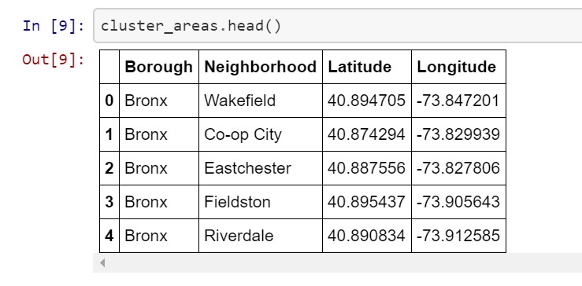

Convert addresses into their equivalent latitude and longitude values. Then we will use the Foursquare API to explore neighborhoods in Manhattan, New York. After that, explore function to get Indian restaurant categories in each neighborhood.

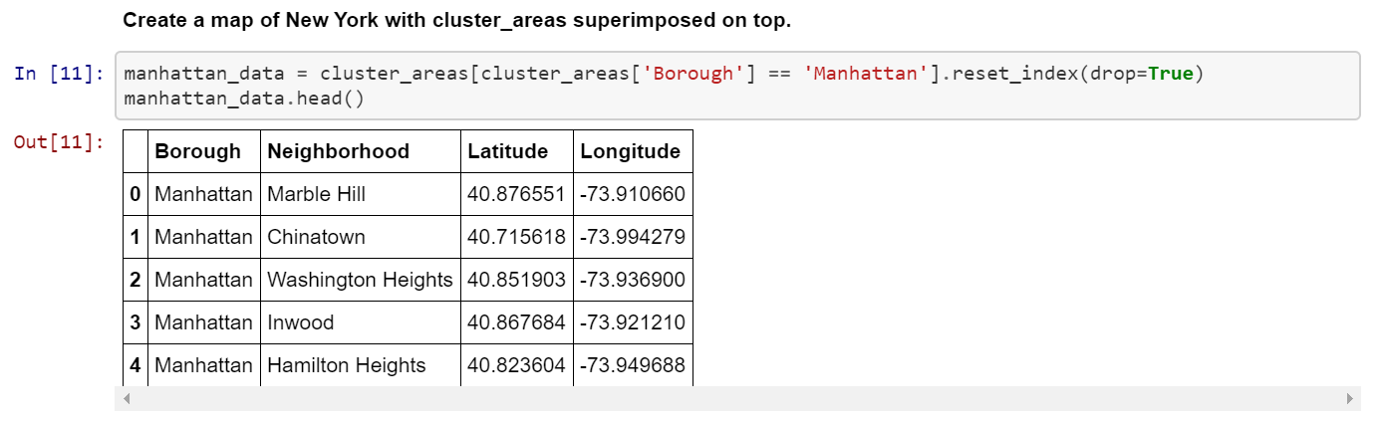

**Indian restaurants in Manhattan, New York**

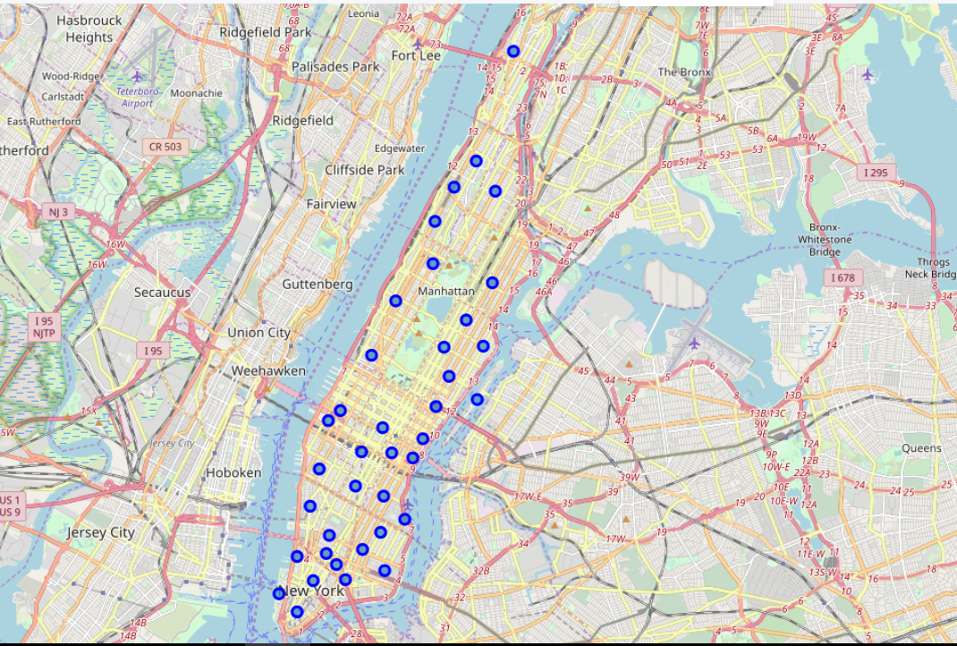

**Clusters created for areas:**

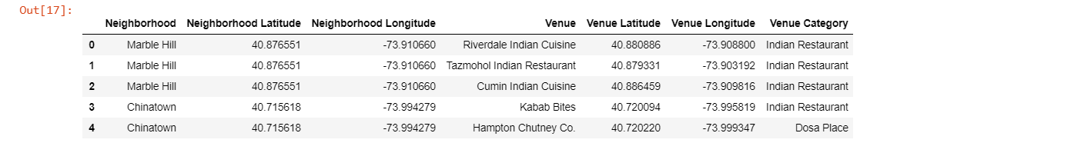

Using the feature to group the neighborhoods into clusters K-means clustering algorithm. Folium library to visualize the neighborhoods in Manhattan and its emerging clusters.

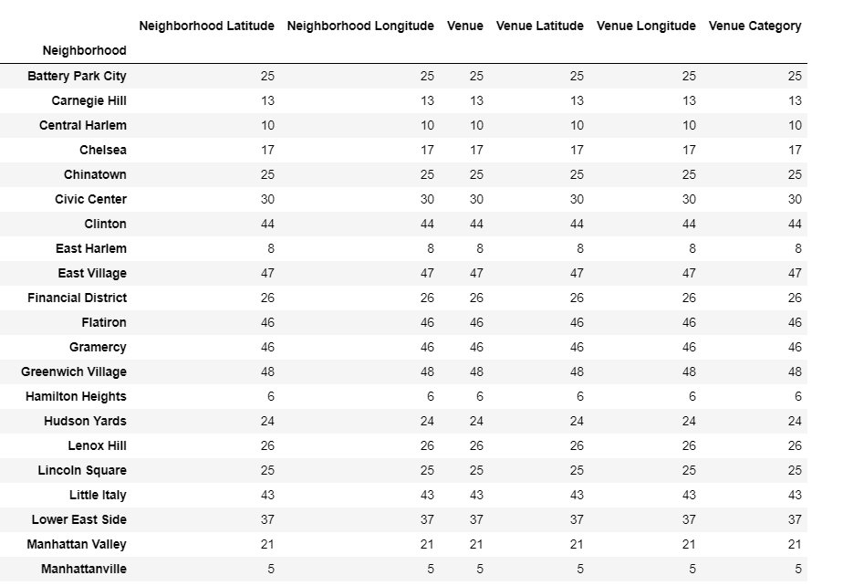

**Analysing each of the neighbourhoods:**

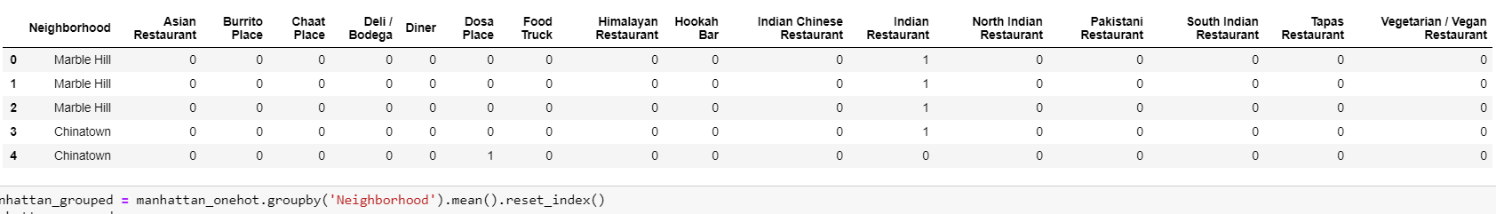

**Indian restaurants in various neighborhoods:**

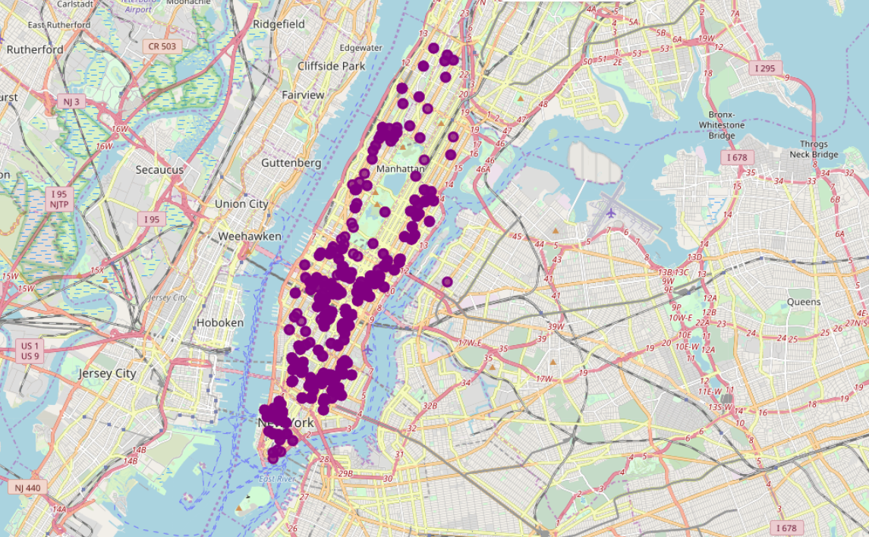

**Grouping the neighbourhods:**

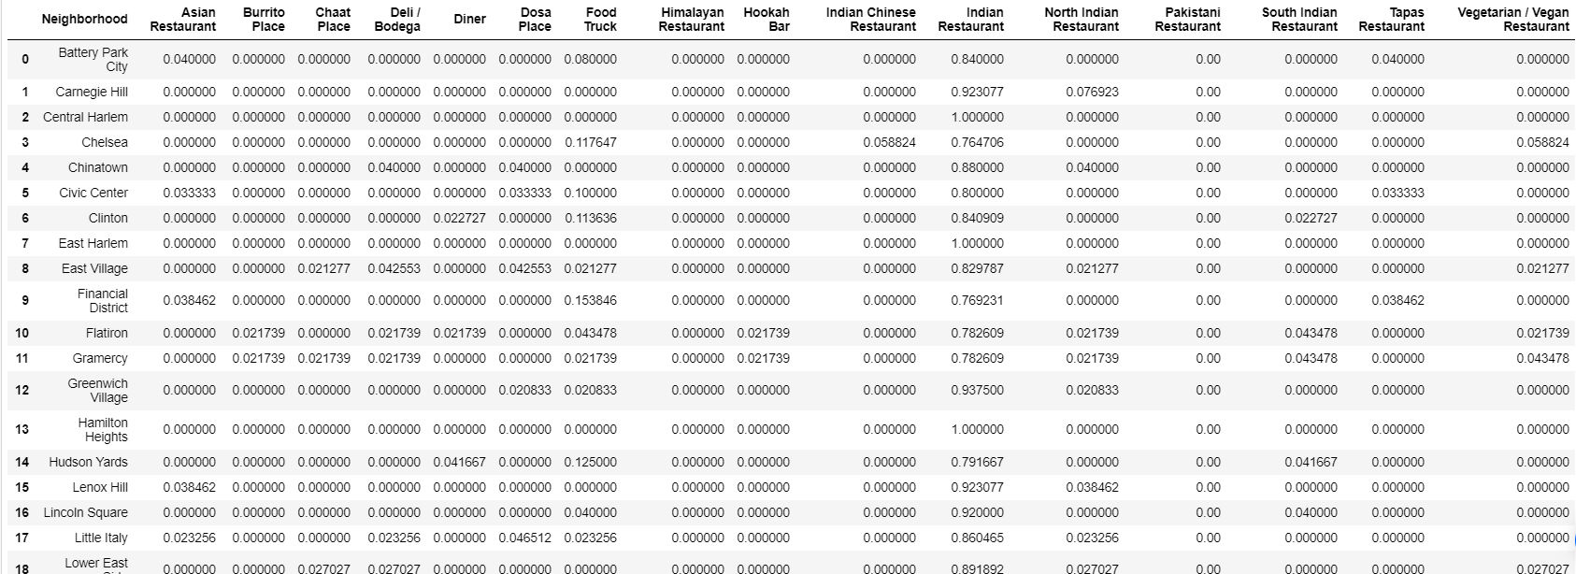

**Result:**

Through Clustering algorithms, the best neighborhoods for Indian restaurants to be set up is Stuyvesant Town.

China town and Marble hill has good presence of Indian restaurants and is not a good neighborhood to have new business

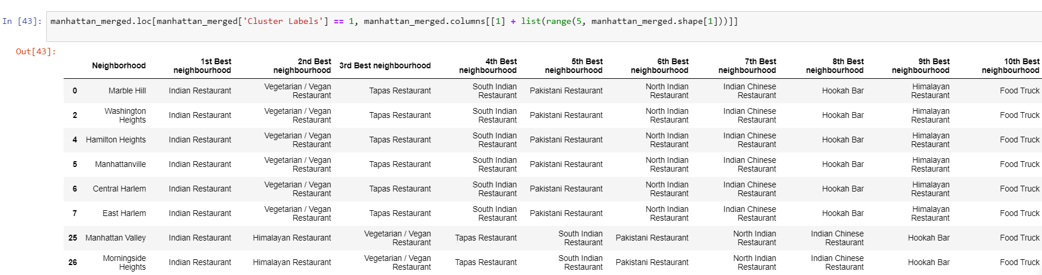

**Conclusion:**

Since all of the goals of project, but still there is still scope for improvement. Best neighbourhoods to have an Indian restaurants is Stuyvesant Town, due to less competition. This neighborhood will hopefully be good for Indian restaurants business